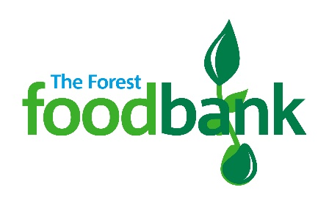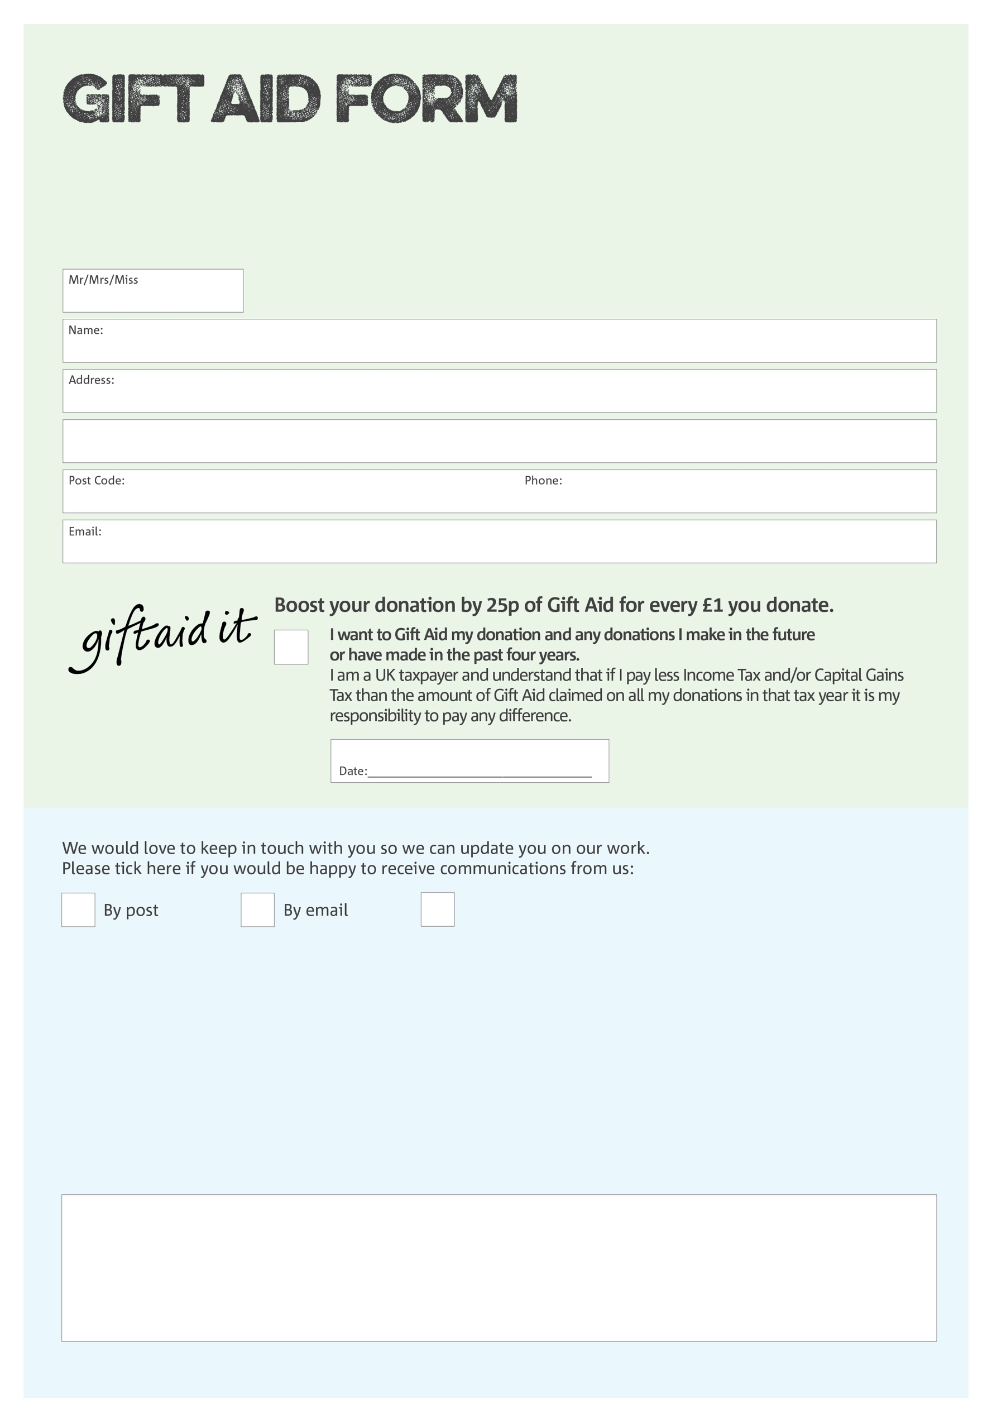

By filling in this form The Forest Foodbank will receive an extra 25p for every £1 you give at no extra cost to you. Thank you!

You can change your preferences any time by contacting us on 07775 265263 or emailing us at

[info@theforest.foodbank.org.uk](mailto:info@theforest.foodbank.org.uk)

Please send this form to The Forest Foodbank Treasurer, 3 Battle Close, COLEFORD GL16 8SF

**Data protection**

The Forest Foodbank is committed to protecting your privacy and will process your personal data in accordance with the Data Protection Act 1998. The Forest Foodbank collects information to keep in touch with you and supply you with information relating to our work. The Forest Foodbank will never sell or pass your details to anyone who isn’t directly working on our behalf. A full data privacy statement for financial donors is available from the foodbank on request.

I do not wish to receive future communications from The Forest Foodbank

We would love to know why you have chosen to donate to The Forest Foodbank. If you would like to share your motivation let us know below:

Part of Coleford Baptist Church, Registered Charity Number 234789 | Registered in England and Wales